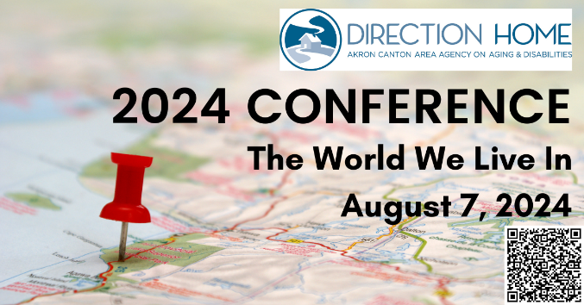​

**Exploring the Nexus of AAAs and MyCare Conversion: Advancements in Integrated Health and Social Care Systems**

**Summary:**

The healthcare landscape is currently experiencing a transformative shift, particularly focusing on integrated health and social care systems designed to offer comprehensive and person-centered services. This workshop aims to investigate the potential role(s) of Area Agencies on Aging (AAA's) and their integration within the innovative MyCare conversion system scheduled for implementation in January 2026. Additionally, the workshop will examine the U.S. Playbook’s Pillars for Addressing Social Determinants of Health.

The workshop aims to provide a platform for informing participants about best practices in advancing integrated health and social care systems, with a specific focus on the potential of the MyCare conversion initiative.

**Learning Objectives:**

* Explore the Evolving Role of AAA's in MyCare Conversion: Investigate the dynamic role(s) of Area Agencies on Aging (AAA's) with the most current information on the redesigned MyCare Ohio program
* Disseminate information about effective strategies and best practices associated with the MyCare conversion initiative
* Examine Ongoing Trends in Integrated Health and Social Care
* Discuss and analyze the U.S. Playbook’s Pillars for Addressing Social Determinants of Health, with a focus on regulatory proposals and rule changes supporting social care integration within the broader healthcare framework